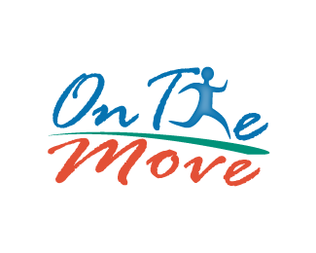
CCBNC Members on the Move
For 2020

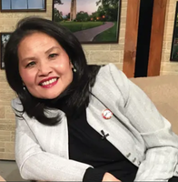
Lily Chen
- Lily Chen, a lecturer in North Carolina Central University’s Department of Nursing, has been named as a Robert Woods Johnson Foundation Clinical Scholars Fellow for 2020-2023.

- Helped to organize and moderate, along with local NC and National Chinese organizations, a Youth Mental Health Webinars. It was attended by over 500+ participants, representing 38 states and other countries (China, Canada, and Singapore). The event was reported in Chinese media ,“The World Journal “ and NC local media with 34k+ reads. “We also felt so overwhelmed with the need with such huge knowledge gap in our community in mental health.”

- Dr. Erma Smith-King and Lily Chen completed the NLN Coaching for Excellence in Nursing that began on August 21 and ended on October 4. The five-module online course was designed for nursing educators to enhance their teaching and learning skills with learners. It covered applying adult learning theory to practice, using Socratic dialogue to promote reflective learning, fostering a safe and effective learning environment, and debriefing critical situations.
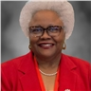
~~~~~~~~~~~~~~~~~~~~~~~~~~~~~~~~~~~~~~~~~~~~~~~~~~~~~~~~~~~~~~~~~~~~~~~~~~~~~~
Dr. Erma Jean Smith-King
- To be Published… A commentary written by Dr. Erma Jean Smith-King, "The Perils of Videoconferencing," was accepted for publication in the NBNA News, a quarterly publication of the National Black Nurses Association. The article explored the science behind video fatigue and presented measures for mitigation and will appear in the Fall edition in December.

- Participate as an Early Voting volunteer for the Chatham County Board of Elections – supported voters in the early voting process at the site located at New Hope Missionary Baptist Church in Apex, NC (Chatham County) from 1 pm to 7:30 pm.
- Was selected as one of six Associate Faculty Fellows to provide support for digital learning across the UNC system for the Fall Semester. The UNC Digital Learning Initiative workshop, Designing Effective Online Courses (DEOC), was offered in two- and four-week modules that enrolled over 2, 200 faculty. She worked with the UNC System Faculty Fellows to facilitate the DEOC workshops. The other five fellows were from UNC-Asheville, North Carolina State University, Western Carolina University, Winston Salem State University, and Pembroke University. She was also selected for the inaugural cohort of Office of eLearning Fellows to assist in scaling support efforts for remote learning to the broader NCCU community for the 2020-2021 academic year.

- Received a grant from Wake Area Health Education Center (WAHEC) to develop a Wellness Clinic that will serve as a practicum site for the RN-BSN students taking community health nursing at North Carolina Central University.
~~~~~~~~~~~~~~~~~~~~~~~~~~~~~~~~~~~~~~~~~~~~~~~~~~~~~~~~~~~~~~~~
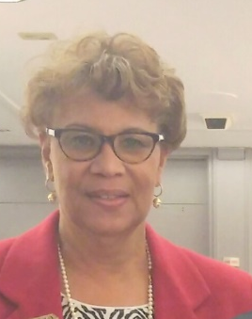
Connie Levister
- Provided over the counter medications to residents of Wake County in conjunction with NC MedAssist.

- Provided backpack personal supplies for homeless men and women in conjunction with the Raleigh-Wake North Carolina A&T Alumni Association.

- Provided towels and washcloths to Southeastern Wake Adult Day Care Center in partnership with Rho Phi Chapter of Chi Eta Phi Sorority, Inc.
~~~~~~~~~~~~~~~~~~~~~~~~~~~~~~~~~~~~~~~~~~~~~~~~~~~~~~~~~~~~~~~~~~~~~~~~~~~~~~
Ashley Brown (Student Member)(No Picture)
- In collaboration with SNA, the Nursing Department, We were able to collect warm clothes, toiletries, personal hygiene products and cleaning supplies for the homeless population who frequent the Urban Ministries of Durham.

- Worked closely with Dr. Sujaya and Professor Chen to collect PPE for the CAARE The Healing Center. These donations of cleaning/sanitizing supplies and masks donated by Professor Chen were donated to help them continue their work in the Durham Community.
~~~~~~~~~~~~~~~~~~~~~~~~~~~~~~~~~~~~~~~~~~~~~~~~~~~~~~~~~~~~~~~~~~~~~~~~~~~
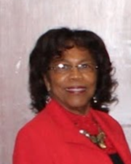
Connie Kelley-Sidberry
- We worked with NCMed Assist Mobile Free Pharmacy to provide free over the counter medications to members in the community. Due to COPID it was a drive thru event, 500 families were served.
  - Participated in the Mobile Food Market/Blessings in a bag at Martin Street Baptist Church. We distributed free food to the community in need via drive by.
300 families were served.

- Worked with the Health and Wellness Ministry at Martin Street Baptist Church to pack fifteen hundred facial masks to be given out at the Blessings in the Bag/Food Giveaway.

- Worked with Rho Phi Chapter, Chi Eta Phi Nursing Sorority to provide with wash clothes and towels to Southeast Raleigh Adult Day Care.

- Worked with the Raleigh-Wake Chapter of A&T State University Alumni Association to provide book bags filled with toiletries, under wear, first aid items, snacks etc. that was given to homeless shelters.

- Participated in zoom meeting about COVID. The purpose was to provide information to individuals who could help to get the information out to churches and other organizations. E-mailed and called individuals to provide them with information about the vaccine.
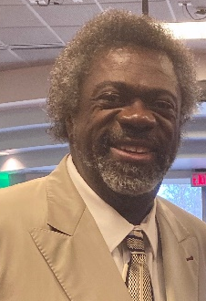
~~~~~~~~~~~~~~~~~~~~~~~~~~~~~~~~~~~~~~~~~~~~~~~~~~~~~~~~
Dr. Ernest Grant
- Dr. Ernest Grant, President of American Nurses Association and NCCU Alum, took time out of his busy schedule to speak at the NCCU community class to speak about health policy. It was very inspiring and informative. Students and faculty members learned a lot about how policy works.
~~~~~~~~~~~~~~~~~~~~~~~~~~~~~~~~~~~~~~~~~~~~~~~~~~~~~~~~~~~~~~~~~~~~~~~~~~~~~~
Angela Spruill
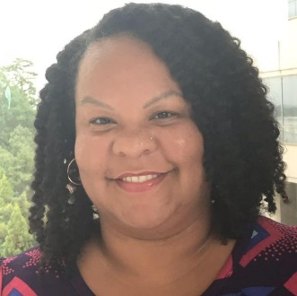
- Assisted with the Sisters Support Group Annual Fundraiser (her mom is a member of this breast cancer support group). Angela was responsible for collecting donations to the group and documentation of the donors and managing sales for and collecting money for the plate sale.
- Was an Oncology Nurses Society Scholarship Reviewer. Reviewed applications for the BSN level scholarship and made recommendations to scholarship chair.

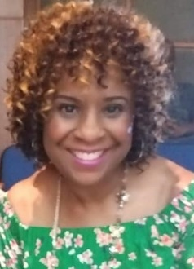
Stephannie Senegal
- Actively participated in mask distribution in the Fuquay- Varina
community
- Is a member of NC Child Fatality task force and Dress for Success
Advisory Board
- Celebrates 30 years employed at Wake County.

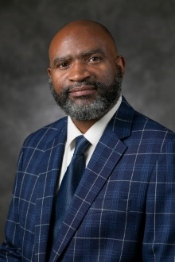
~~~~~~~~~~~~~ ~~~~~~~~~~~~~~~~~~~~~~~~~~~~~~~~~~~~~~~~~~~~~~~~~~~~~~~~~~~~~~~
Angelo Moore
Angelo was remarkably busy participating in, moderating, and speaking in many virtual community forums for the community at large and healthcare personnel as part of his responsibility with Duke Cancer Center Outreach Programs. See the list below:
- Developed and lead a community educational social media event via Facebook live about colorectal cancer education, prevention, and screening. Reached about 2,000. This event won the 2020 SCOPY Award from the American College of Gastroenterology for the “Best Culturally Inclusive Social Media Event.”
- North Carolina Oncology Navigation Association Conference for North Carolina Navigators. The focus was to provide a presentation on Community-Facing Patient Navigation and how these professionals assist individuals in getting necessary cancer screenings and treatment as well as access to primary care services. There were 200 attendees at this presentation.
- Durham Technical Community College Lecture - Provided lecture on prevention, screening, and maintaining chronic diseases, common cancers, and sexually transmitted infections. Attendees: 21
- Women’s Health Awareness Breast Cancer 101 Education Session – This audience consisted of community members and health care personnel. Angelo moderated community educational session on breast cancer education, prevention, screening, and treatment. Attendees: 20
- Office of Health Equity Breast Education Session - Community members and health care personnel. Developed and lead a community educational session on breast cancer education, prevention, screening, and treatment. Attendees: 25.
- Virtual Education Session: Focus group, community members and health care personnel. Provided a presentation related to how the healthcare system works, the different levels of care, the importance and benefits of primary care, and available community resources. Number of Attendees: 30.
- Office of Health Equity Stomach and Gastric Cancer Education Session: Developed and lead a community educational session on stomach and gastric cancer education, prevention, screening, and treatment for approximately 20 community members and healthcare personnel.
- Office of Health Equity Lung Cancer & Tobacco Cessation Education Session: Developed and lead a community educational session on lung cancer education, prevention, screening, and treatment. Also provided free resources to tobacco cessation resources for an audience of 40 Attendees.
- American Cancer Society National Navigation Roundtable: Provided a presentation on Community-Facing Patient Navigation to include demonstration of effectiveness through as case study. Number of Attendees: 125
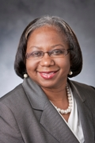
~~~~~~~~~~~~~~~~~~~~~~~~~~~~~~~~~~~~~~~~~~~~~~~~~~~~~~~~~~~~~~~~~~~~~~~~~
Priscilla Ramseur
- Priscilla announced that she is the Board Chair of the NC Foundation of Nursing. The Foundation scholarship application will open in January 2021.
Any nursing student in NC schools can apply regardless of level. Applications are electronic.
- She also had the opportunity this Summer to participate in Duke’s initiative to heighten awareness of racism . This initiative was titled Moments to Movement which spotlighted Black Women at Duke and in America. She will send the link to the presentation.
- Priscilla was a co-panelist at the Zeta Phi Beta Sorority, Inc.; Eta Beta Zeta Chapter Durham, NC’s COVID-19 Vaccination Conversation (20 attendees).
- She was selected and honored as a “2020 Living Nurse Legend” by the Pi Chapter of Chi Eta Phi Sorority, Inc.

~~~~~~~~~~~~~~~~~~~~~~~~~~~~~~~~~~~~~~~~~~~~~~~~~~~~~~~~~~~~~~~~~~~~~~~~~~~~

LeeAntionette Moore (No Picture)
- LeeAntionette was photographed for several picture in the Spring 2020 issue Minority Nurse. The article is entitled" The School Nurse - Fully Engaged in Community Health". The photos are on pages 23-24...….
https://issuu.com/minoritynursemagazine/docs/mn_spring_2020
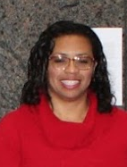
~~~~~~~~~~~~~~~~~~~~~~~~~~~~~~~~~~~~~~~~~~~~~~~~~~~~~~~~~
Darlene Cooper
Darlene was the recipient of the “NC Great 100 Nurses Award” in 2020 at the 32nd Annual NC Great 100 Gala. The gala was held virtually due to COVID-19 Pandemic.
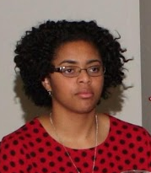
~~~~~~~~~~~~~~~~~~~~~~~~~~~~~~~~~~~~~~~~~~~~~~~~~~~~~~~~~~~~~~~~~~~~~~~~~~~~

Kiana Cooper
Kiana was chosen as CCBNC’s Distinguished Service Award recipient for 2020. She was recognized for this honor at the Annual Retreat Meeting which was held virtually.

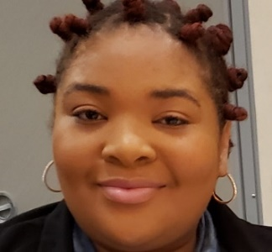
~~~~~~~~~~~~~~~~~~~~~~~~~~~~~~~~~~~~~~~~~~~~~~~~~~~~~~~~~Diamond Tillman
Congratulations to Diamon for passing the NCLEX! She is now an RN!

~~~~~~~~~~~~~~~~~~~~~~~~~~~~~~~~~~~~~~~~~~~~~~~~~~~~~~~~~~~~~~~~~

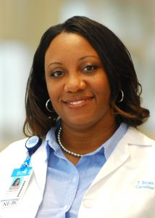
Turkeisha Brown
Turkeisha Brown, MSN, RN, NE-BC, Patient Services Manager III, leads 70 employees on 6 Bedtower, a designated acute care unit for COVID-19 patients at the UNC Medical Center in Chapel Hill. Through obstacles, trials, and determination, her staff is unified to help fight the deadly SARS-CoV-2 virus.
Click on the link to read more - https://news.unchealthcare.org/2020/07/on-the-front-lines-of-covid-19-nurse-manager-turkeisha-brown-leads-her-team-through-a- pandemic/

