NBNA SUMMER NEWSLETTER
Members-On-The -Move
CCBNC

August 2019

Great 100! Congratulations to Yolanda Neal, RN. She is being honored and recognized as one of the 2019 GREAT 100 nurses in North Carolina. Yolanda works at Duke University Health Systems – Duke Regional. The 31st Anniversary Celebration Great 100 Gala is being held on Saturday, October 5, 2019 at the Concord Convention Center in Concord, NC.
Thanks, Yolanda for carrying on CCBNC’s mission in the workplace. We are so proud of you!
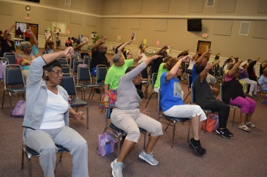
Connie Kelley-Sidberry, Chair of Martin Street Baptist Church Health and Wellness Ministry along with her committee hosted a Healthy Event at the church on June 22nd to celebrate its 150th anniversary. The event was titled “Sight! Sound! & Action! 150 Years and Moving - Taking Care of God’s Temple through HEALTHY Eating and Exercise.” It was a fun filled morning complete with chair exercises, Tai Chi, Line dancing and Healthy Lifestyle and Eating Tips. Participants had an opportunity to win prizes, eat healthy snacks and received a goodie bag to take home. Members Connie Levister and Helen Horton participated in the event.
~~~~~~~~~~~~~~~~~~~~~~~~~~~~~~~~~~~~~~~~~~~~~~~~~~~~~~~~~~~~~~~~~~~~
Helen Horton represented CCBNC at the first Annual Health at Mount Staunton Memorial CME Church in Pittsboro, NC on June 8th. Helen presented information and educational materials on Heart Disease and Diabetes to the approximately 45 participants. Participants also had the opportunity to win 5 free gifts.

Members Angelo & LeeAntionette Moore, Bertha Williams, Wanda Wilkins, Connie Kelley-Sidberry, and Helen Horton attended the Community Health Coalition (CHC) Annual Community Dinner and Gala at the Durham Convention Center, Durham, NC on May 30th. This was CHC’s 30th anniversary celebration and launch of Healthy People 2030. The event, entitled “Healthy People: Progress and Policy: Eliminating racial health disparities in Durham and surrounding areas. There were approximately 200-300 community members, leaders, politicians and vendors who attended the event.
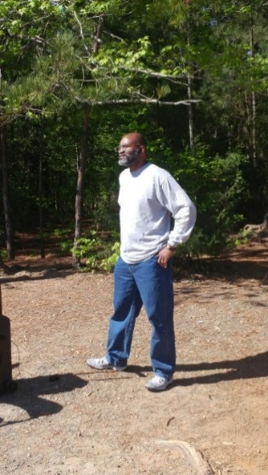
Angelo Moore and Helen Horton participate in the 100 Black Men Community Health Fair and Sports Day on Saturday, April 27th. They manned the First Aid Station for the event. Fortunately, there were not incidents requiring services.

~~~~~~~~~~~~~~~~~~~~~~~~~~~~~~~~~~~~~~~~~~~~~~~~~~~~~~~~~~~~~~~~~~~~~
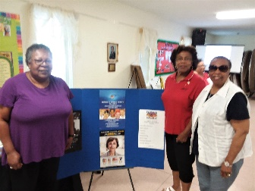
We cannot talk about being healthy without talking about what we eat. Triangle Stroke/Minority Women’s Health Alliance, a Community Public Health Advocacy, Information/Educational and Outreach organization decided to bring important information to the community. This organization is made up of many community organizations, professional groups and churches. Connie Levister and Connie Kelley-Sidberry represented Central Carolina Black Nurses, Inc.
May 25, 2019, the organization had a “Supermarket Roundtable: “Build a Better Basket Health Fair” Consumers were able to sample various food, learn about healthy choices, vegetarian cooking, sugar-free baking and so much more. There were a variety of speakers, a sample of topics covered were the health benefits of plant based eating, , organic food, the new guidelines for blood pressure and natural home remedies This is the third year having this Health Fair, each year it gets bigger and bigger.
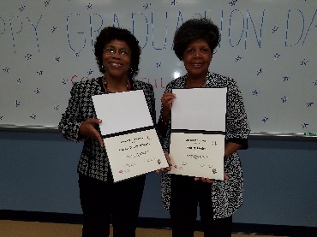
~~~~~~~~~~~~~~~~~~~~~~~~~~~~~~~~~~~~~~~~~~~~~~~~~~~~~~~~~~~~~~~~~~~~~~~~~~
Connie Kelley-Sidberry, a member of Central Carolina Black Nurses’ Council, had the opportunity to go back to college. This was a very special college held at North Carolina Agricultural and Technical State University in Greensboro, North Carolina. This was a Caregiver’s College for church leaders who are or may have been Caregivers. COAACH stands for The Center for Outreach in Alzheimer’s Aging and Community Health. This C3 is a community-engaged and intervention-based education program, which is designed to increase awareness, case management and health outcomes to families impacted by Alzheimer’s diabetes and related conditions.
Some of the modules presented were 1} Understanding Alzheimer’s Disease, 2} Diabetes Prevention and Management, 3} Legal and Financial Planning for the Caregiver, and Emergency Preparedness’.
The program was very informative and as part of the training each participate is required to do at least three programs at their church or in their community. The last day of the program was graduation, we marched in to “Pomp and Circumstance” and received a diploma as a Lay Health Ambassador.

